MASSACHUSETTS BAY COLONY
WERE THE PURITANS SELFISH OR SELFLESS?

Historical Context: The Puritans were a group of people who criticized (wanted to “purify”) the corruption and hierarchy (chain of command) in the Church of England in the 1600s. The Church of England was the official church in England that everyone automatically belonged to. Puritans believed that the final authority came from the Bible, not from church officials, and therefore, every individual had direct access to the word of God. Some Puritans wanted to completely separate from the Church of England (they were called Separatists). The group of Pilgrims who came on the Mayflower in 1620 were Separatists. 10 years after the Mayflower, a group of Puritans, led by John Winthrop landed in New England and established the Massachusetts Bay Colony. They were still loyal to the Church of England, but believed they could purify the behavior of individuals (purify the Church from within). The documents below is a depiction of the Pilgrims in 1621 and two speeches by the leaders of the Puritans who formed the Massachusetts Bay Colony to see if we can figure out how they believed they should act in the New World.

Document A
Source:
This painting by J.L.G Ferris, titled The First Thanksgiving 1621, was published in 1932.

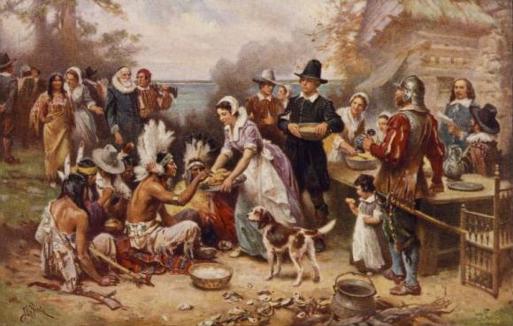

“The painting The First Thanksgiving 1621 is a useful resource for historians who wish to understand the relationship between the Wampanoag Indians and the Pilgrim settlers in 1621.”

Doc A Question: Do you agree or disagree with the above statement? Briefly support your answer.

Document B: ‘City upon a Hill’ speech by John Winthrop

Source: John Winthrop (1588–1649), lawyer and leader of the 1630
migration of English Puritans to Massachusetts Bay Colony, delivered
this famous sermon aboard the Arbella to settlers traveling to New
England.

The only way to provide for our posterity (future generations) is to do justly, to love mercy, and to walk humbly with our God. We must be knit together in this work as one man; we must take care of each other with brotherly affection.

We shall be united in the bond of peace, the Lord will be our God and delight to dwell among us, so that we shall see much more of his wisdom, power, goodness and truth.

We shall be as a City upon a Hill, the eyes of all people are upon us; so that if we shall [behave badly] and cause God to withdraw his help from us, we shall [invite] the mouths of enemies to speak evil of the ways of God, and cause their prayers to be turned into curses upon us.

Therefore let us choose life, that we, and our [children], may live; by obeying his voice, for he is our life, and our prosperity. (wealth)

Doc B Questions:

1. Sourcing: Who was John Winthrop speaking to in this sermon? What do you
think is the purpose of this sermon?

2. Contextualization: Imagine what his audience might have been thinking and
feeling as they listened to him on the ship. Describe it below.

3. Close reading: What is the main idea of this speech? What do you think
Winthrop means when he says, “We shall be as a City Upon a Hill?”

Document C: ‘The Divine Right to Occupy the Land’ speech by John Cotton

Source: Puritan leader John Cotton gave the following sermon to members of his congregation who were immigrating to America in 1630. Cotton became a respected and influential clergyman in the Massachusetts Bay Colony.

The Bible says: “I will appoint a place for my people Israel, and I will plant them, that they may dwell in a place of their own, and move no more.”

The settling of a people in this or that country is the Lord’s decision.

Now, God makes room for a people in three ways: First, He drives out the heathens before them by waging war on the inhabitants.

Second, He gives a foreign people favor in the eyes of any native people to come and sit down with them.

Third, He makes a country empty of inhabitants where the people will live. Where there is an empty place, the sons of Adam and Noah are free to come and live there, and they
neither need to buy it nor ask permission.

Doc C questions:

1. Sourcing: Who was John Cotton speaking to in this sermon? Why is he
speaking about settling in a new land?

2. Contextualization: In this sermon, who are the ‘inhabitants’ in the new land?
Who are the ‘foreign people?’

3. Close reading: What does Cotton say that God will do for the foreign people
when they arrive in the new land?

Based on these documents, how might the Puritans’ religion shape
their actions in the New World? Cite evidence from the documents in your responses. Put the author of the source in paranthesis following the quote you use to support your claim.

Example: “Quote from Winthrop’s sermon speech.” (John Winthrop)

- How do you think Puritans would have reacted to someone who strayed from the religion? Why?

- How do you think the Puritans reacted to the Native Americans they encountered?

- Were the Puritans selfish or selfless?

Citations:

John Winthrop, “City Upon a Hill,” 1630.
http://religiousfreedom.lib.virginia.edu/sacred/charity.html

John Cotton, “The Divine Right to Occupy the Land,” 1630.
http://www.pragmatism.org/american/docs/cotton_divine_right.htm

J.L.G Ferris, titled The First Thanksgiving 1621, published in 1932.

